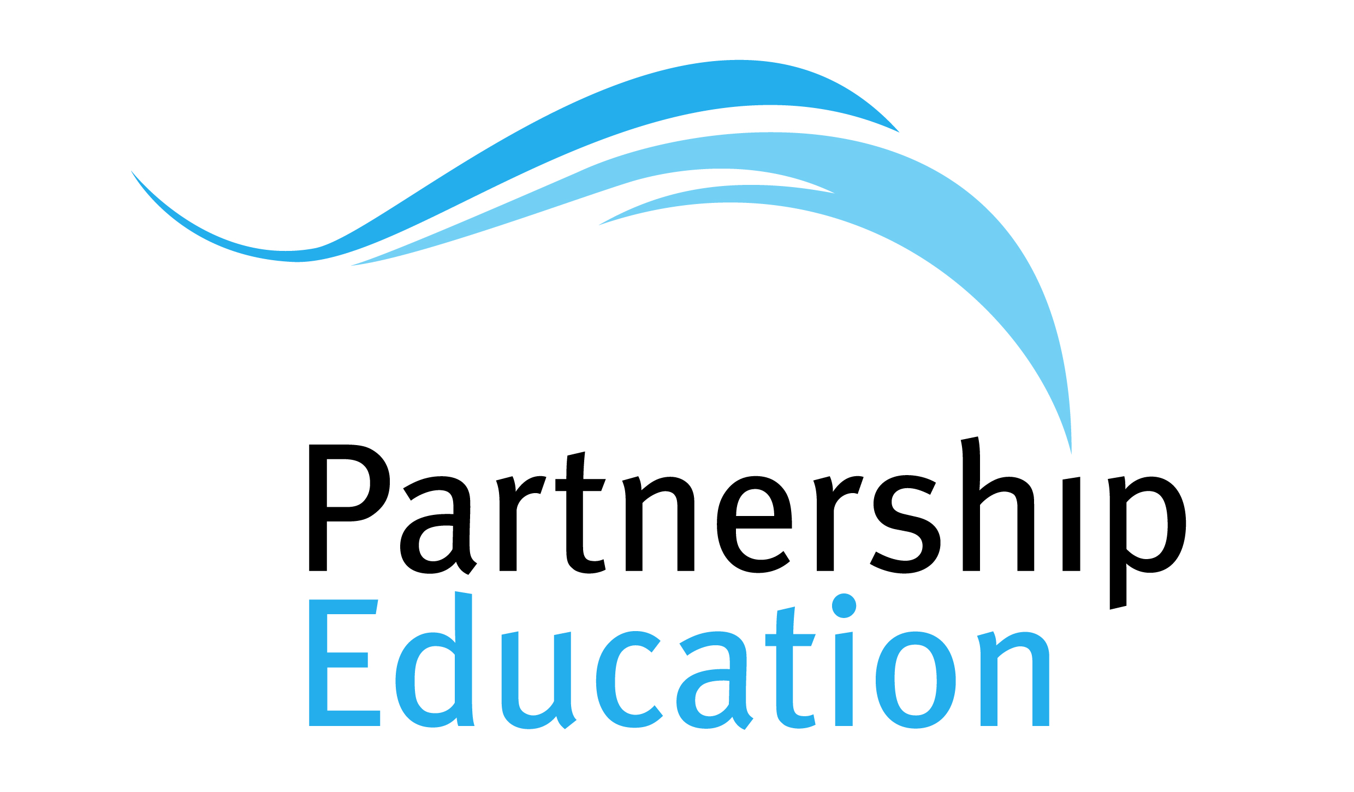
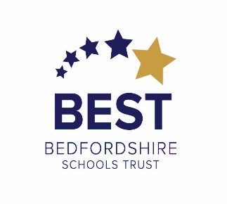
Do you know your phishing from your spoofing? Your password complexity from your anti-virus protection? If not, then this could be your answer.

The online world can be both a powerful tool to access the world’s information, but also an ecosystem full of risks and dangers. There were a record 3.6 million incidents of online fraud in the UK and Wales in 2018 (ONS 2018), where 6.6% of victims had been affected more than once. Make sure you are not one of them!

BEST, in association with Partnership Education, will be hosting a FREE training session for the wider community to help provide you with useful information, practical advice and guidance along with tips and tricks to protect yourself online.

So if you have concerns yourself, or know someone that could do with some advice and information in a friendly and relaxed setting, we’d love to see you.

When: Monday 27th January 2020
Where: BEST House, Shefford Road (next to Samuel Whitbread Academy)
Time: 1.00pm to 2.30pm

No need to book – just turn up and join our IT specialists as they guide you through this sometimes confusing and potentially risky arena.

Tea and coffee will be available.

We look forward to seeing you there.

